In Chapter 2 of Capital Vol 1., Marx was tracing the determinants of the exchange process, particular for bourgeois society, in its initial conditions. Which begins with the social movement of commodities, by one side, and money in the other extreme of exchange relations.
The first distinction presented by Marx as a determinant of the exchange process of the bourgeoisie society is the differentiation between the commodity and the bearer. For the [bearer] his commodity possesses no direct use-value [[KV1C2P179L13]]. For himself, it is only use-value as mean of exchange [[KV1C2P179L15]].
The second, is the determination of a universal equivalent as a consequence of the expansion of the exchange process. From the perspective of the individual, each of the bearers treats his own commodity in exchange as the universal equivalent for all other commodities.
The third one corresponds to the transformation of gold, the money-commodity, into monetarized capital. In the transition between the exchange of use-values, and the exchange of commodities, there is a determinant detail. And more than a detail, the particularity of the exchange process, an original mistake, a social accident, acted first then thought, to treat something, that is not for being appropriated as a commodity, as if it was a commodity.
The historical expansion and intension of the process of exchange is also the process of taking everything that is possible to be treated as something to being appropriated (LCWV38P108L17), as if it was a commodity, With the purpose of appearing as its owner, seeking to receive an equivalent exchange-value in the money-form of exchange-value. That movement, the mechanical and unreflective, unethical application of the logic of dialectics, the power of alienation, therefore appropriation of something not being for appropriation, and the later sublimated freedom of money from gold as its elementary form of value. Ideally placed exchange value and value somewhere outside the elementary form of everything with price.
The determinants of the exchange process are rooted in the history of the formal social movement of the commodities, because the exchange of use-values in upward scale-shift, requires a relative form of value reached by social accident by one commodity which is both commodity and money: gold, and also other precious metals in history, became universal equivalents [[KV1C2P180L24]]. Fixing its use as a means of exchange, appearing in the process of exchange as a sign of magnitude for the quantitative equivalence of the exchange-value form of all the commodities, as the universal equivalent commodity under certain scale of circulation.
With the escalation of its compulsive subsumption by circulation over the exchange process, money is used (first in theory, and then in real) as a determinant of the “need to give an external expression to this opposition [between use-value and value which is latent in the nature of the commodity] for the purposes of commercial intercourse”. The upward scale shift of the exchange process mediated by money produced the drive toward the invention of an “independent” form of value, which finds neither rest nor peace until it became “independent from its own use-value” [[KV1C2P182L34]] completed the differentiation of all commodities into commodities and money.
Therefore, the value of everything is distinguished from its usefulness for exchange, and signed with price [[KV1C2P187L9]], by an imagined quantity of monetized capital valorized as an ideally equivalent quantity of expended human labour.
Why the indigenous alienable wealth became gold and silver, and aren’t anymore nor cattle neither slaves? Is because gold and not the slave was already the social form of money when the “discovery” of silver and gold mines of America occurred.
After genocide and slavery, in the exchange process, the mercantile capitalist as bearer of that commodity-money purposely treats something as the “chief element of indigenous alienable wealth” [[KV1C2P183L18]]. As if it doesn’t have use-value outside its exchange-value form. They treated gold as pure money, and not as commodity-money. Not all the mercantile capitalists could understand at the same pace the value of labour for the circulation process, this means, the valorization process of exchange-values.
But certain industrial capital was in formation, incorporating the value of labour into the valorization process of gold as a commodity in its circulation toward its money-form of value. Besides its circulation as a means of payment, gold is then produced for hoarding. At the same time, gold mining was already a branch of production centralized in the hand of capitalist production, before, during, and after the transition of mercantile capital into industrial and finance capital.
So, the social accident of the expanded circulation of gold-money as capital and mainly the decision to use it as a means for exchange, as a universal equivalent, was not an accident for the individual gold bearer producing and hoarding the money-commodity of gold. That one, then, later, became the bearer of finance capital. Who as hoarder of the money-commodity wants to exchange every other commodity as metallized-money, monetized money, monetarized money or crypto-money, avoiding the alienation of his money-gold in the process of circulation as a means of payment.
“The difficulty lies not in comprehending that money is a commodity, but in discovering how, why and by what means a commodity becomes money.” [[KV1C2P186L24]]
Chapter 3 of Capital explains the social functions executed by money in the circulation process. Marx distinguished money, first, as a measure of value, as the social incarnation of labour expressed in price or money-form. An imaginary quantity of gold ideally equivalent to the labour time socially necessary to produce the correspondent quantity of standard units of price defined by a fixed weight of gold. Which became the universal equivalent commodity and indeed the money-commodity.
The process of exchange finishes in the realization of commodities as exchange-values. So, it is by consumption, which for the particular social formation of interest (bourgeois society) is realized with the payment of the commodity price (C): as the magnitude of the general measure of the exchange value for every commodity produced by, for, and as, capital.
By the realization of the exchange process, by the purchase of a commodity, the use-value produced as a commodity for capital reproduction can be appropriated. As the circulation of commodities is mediated by money (C-M-C), the distinction between commodities and money-commodities, later developed in the liberalization of its exchange-value from its elementary form, by creating the money-form of value from the metal rips of the precious metals which as gold functioned as prima inter pares universal equivalent commodities.
"But what is the commodity exchanged for? For the universal shape assumed by its own value. And what is the gold exchanged for? For a particular form of its own use-value". The form of gold as use-value, which Marx referred to in the quotation cited above, is the standard of price, which is a fixed weight of gold (i.e. ounce of gold) operating as the unit of expression shared by their comparable magnitudes of price. Indeed, the circulation of the commodities and their transubstantiation into money can be differentiated, first, by their exchange scale.
So, the chance of social accident by which the circuit M-C-M' is being obstructed, mediate between the necessary conversion of commodities into money, correspondent to the process of transformation of surplus-value into profit. Is it not in the transition forms in which we should pay attention?
What is to be done?
Historically, the exchange process produced the accumulation of gold as a universal equivalent commodity which became money-commodity. At the same pace the production of gold reaches the circulation process, “gold […], in its crude state, becomes immediately, on its emergence from the bowels of the earth, the direct incarnation of all human labour” [[KV1C2P187L18]].
With the liberalization of gold price, since 1971, the total monetary system debased money from its elementary form. As if in that manner, the use-value of gold as the socially formed universally equivalent, would be suppressed, and replaced by certain specific currency (USD), fixed by a hegemonic arrangement relying only on U.S. hegemony.
The liberalization of the price of money from its standard of price expressed in a fixed weight of gold as the elementary value form of money-commodity, raised the price of gold exponentially as well as propel another gold rush. But, as gold didn’t lose completely its properties, its physical properties as standard of price, central and international banks hoard it with extended voracity, while at the same time state capitalism is benefiting from the exponential upward of the gold-commodity price effecting in the exchange value of its national reserve gold fund.
Is the total sum of the different prices of the money-commodity circulating as world money expressing “the direct incarnation of all human labour” [[KV1C2P187L18]] through the production of gold?
Still considering gold production, the production of gold as a money-commodity, as the process on which the joint “social process of production in a purely atomistic way” [[KV1C2P187L20]] “assume a material shape [the gold standard of price]. [W]hich [appropriation] is independent of their control and their conscious individual action” [[KV1C2P187L22]].
Really, we know that the appropriation of gold is dependent on our control of the territories, cursed and not blessed by productive mines. The antimining struggles are in that sense, mediating between the chances and the social accidents which determine the realization of the accumulation of profits, produced by the exploitation of the total labour advanced in a certain period. Labour is in that sense, overdetermining the profit rate fall, not only as variable capital, but historically, getting back at the circulation process with the natural power of class struggle.
Also, while the imaginary, ideal, character of the money-form of value or price of the commodities, highlight the fictitious essence of money and its permanent expulsion from the circulation process of commodities (C-M-C); the relevance of the analysis of the standard of price for the study of the reproduction crisis of finance capital may be critical for the development of theoretical assumptions build over Marx's critique to the political economy of the bourgeoisie society, considering the reforms to the gold standard of the international monetary system during 1968 and 1971, and its actual shift under the present critical juncture of transition to a new international monetary system, non-restricted by the dollar hegemony.

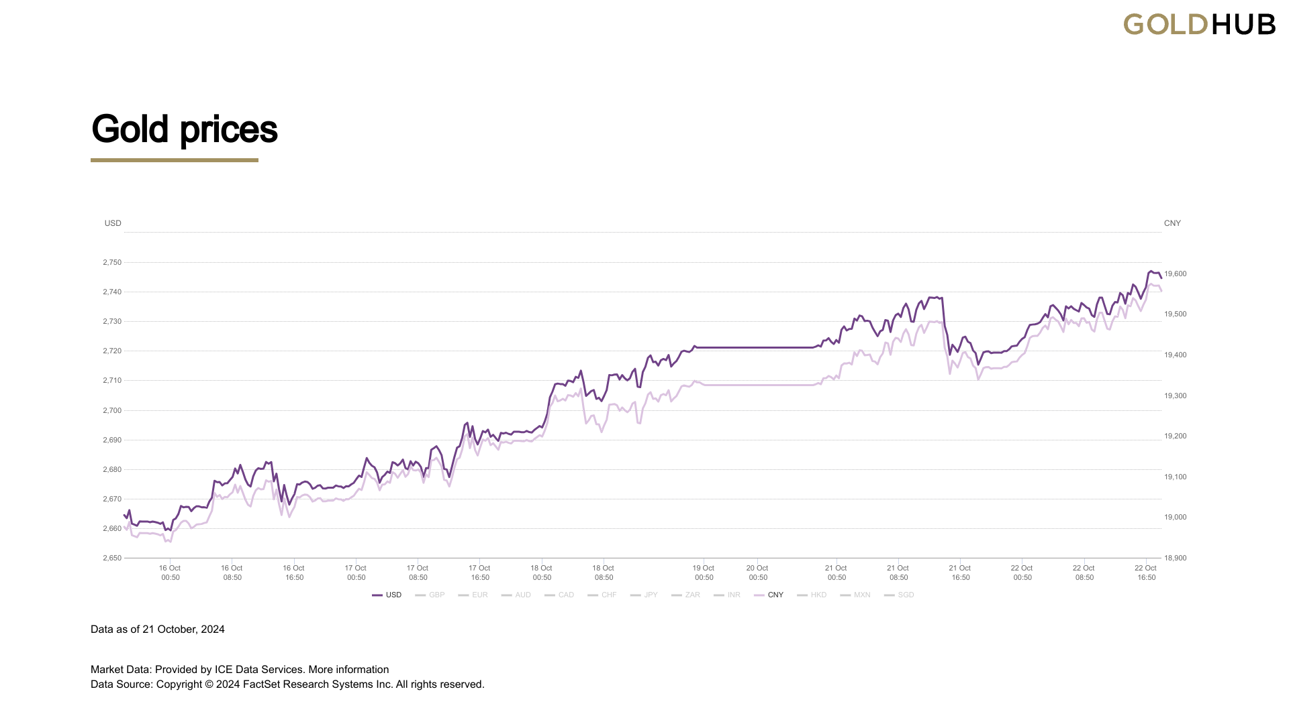
Figure 1. Historical gold prices since January 2, 1980 to October 22, 2024 in USD and CNY.

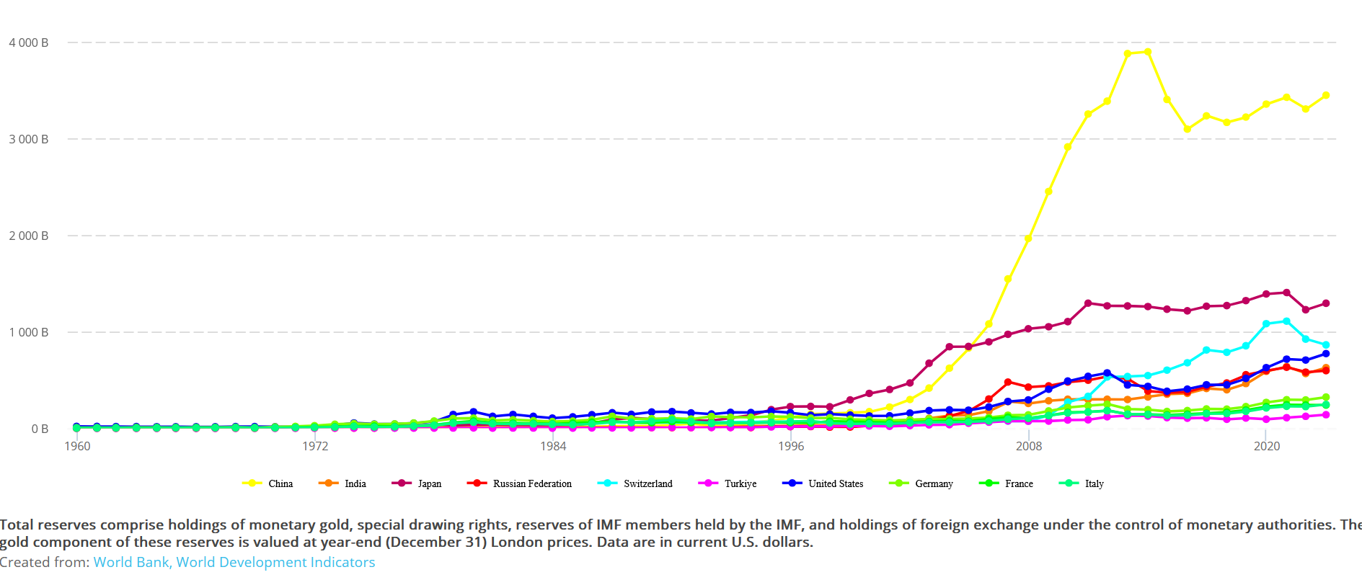
Figure 2. Total monetary national reserves measured in USD for the ten main gold hoarding states, 1960-2023.

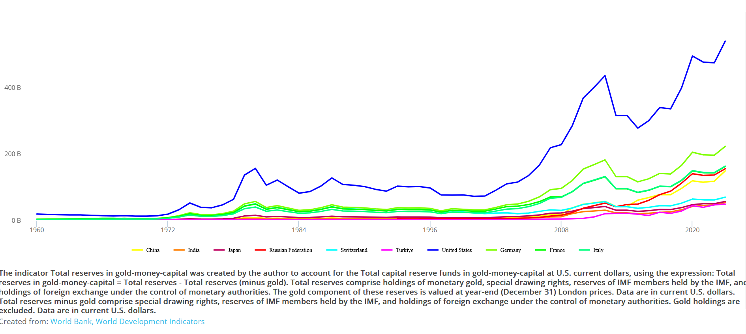
Figure 3. Total gold national reserves of the ten main gold hoarding states, 1960-2023.

